Title:

Domain:

Abstract:

In the recent proximity of time we have seen security and intelligence flaws resulting to the terror attacks on roads. We use an assumption that after the attacks at any particular roads or highways there would be security barriers put up for the checking of all or suspicious vehicles. In this project, using this assumption we put forth a semi-intelligent cop assisting system TIE(The Invisible Eye) which would sense few parameters(not directly known to the security personnel(s) or for that matter any individual at their first glance on the vehicle) of passing vehicles and make them available to the security personnel(s) on the barrier who is supposed to check the vehicle. Also the system can be deployed in a way the passengers can not notice the presence of it.

Problem Definition:

We saw a huge loss of human lives in the Pulwama attack that took place on 14th Feb 2019[1].

Pointing out one of the reasons for the attack to be the removal of 3 barriers from the road where the incident happened Prof. Amita Singh(Professor of Law, Governance and Disaster Studies at Jawaharlal Nehru University) said, “The RDX filled vehicle could not be checked as the 3 check barriers were removed by mehbooba mufti...”[2][3]. The potential correctness of the statement by Prof. Singh and other parameters that directly or indirectly contribute to the vulnerability of the road the incident happened. Hence there arises a need of a system that assists the security personnel(s) in tracking the parameters unusual to the vehicle at the same time being unnoticeable by the malevolent and criminal individual/groups.

Literature Survey:

Proposed Architecture:

We assume a scenario where there are 3 security barriers in place on a road that needed high security & safety maintained on it. Each barrier has an official sitting on a computer system and another few manually checking the passing vehicles. Every vehicle in the queue has to wait for the checking of the vehicle ahead of it to be cleared. The TIE System runs to scan weight & temperature of the vehicle while it is in this waiting state. Although the people in the car or around it aren’t aware of the scan.

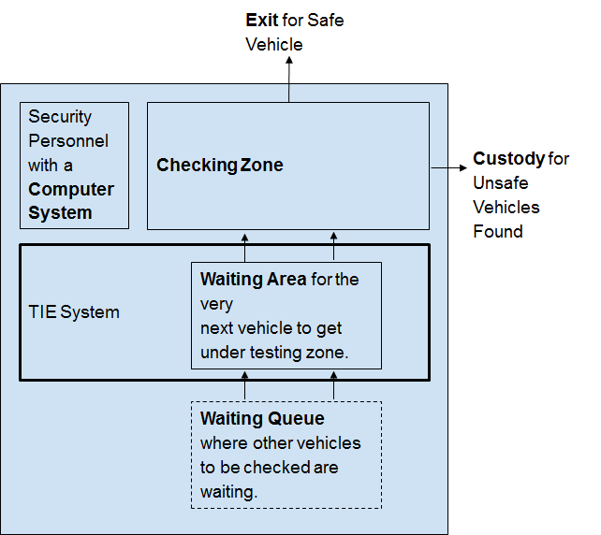

Fig 1. System Deployment Positioning Diagram

Scan Weight

Take thermal image

Microcontroller

Computer System

Intelligent System

Output Console

Security

Personnel

Vehicle Under Check

**TIE SYSTEM**

Fig 2. TIE System Architecture

Expected Outcome:

The system should assist the security personnels positioned near the barriers to check either all or just the suspicious vehicles passing by the barriers. The system would sense the weight of the vehicle while it waits for a go-ahead from the security personnels & would take the thermal image of the car simultaneously and would send them to the software deployed on the computer system of the another security personnel or same. And on-the-fly the software would apply algorithms to find the unusualness in those parameters, assign a vulnerability index to the vehicle & show the results to the security personnel. Doing this the examination of the vehicle in a particular way or intensity can be done. This would also help in other two ways

1. When population of cars passing by the barriers is large enough the system will help in finding the ones that need to be thoroughly checked by the security personnels with respect to weight & temperature/thermal attribute of the vehicle under check.
2. It would help them to know the magnitude of parameters which one cannot find manually & feasibly in all circumstances.

The system is expected to work in the following range of temperature {WRITE}.

References:  
[1]. <https://www.livemint.com/news/india/pulwama-terror-attack-death-toll-rises-to-40-jem-claims-responsibility-1550143395449.html>

[2]. <http://www.newindianexpress.com/nation/2019/feb/20/jnu-prof-says-mehbooba-mufti-ordered-removal-of-barriers-that-led-to-pulwama-attack-pdp-to-take-leg-1941055.html>

[3].

<http://scdr.jnu.ac.in/team/prof-amita-singh-pi/>

[4].

TIE sensors:

For a traditional sensor to be called a TIE sensor it should satisfy following conditions:

(1). The sensor has proper datasheet available

(2). It can stably operate in the temperature range {WRITE}

(3). It should be possible to cover it in a way it becomes unnoticeable by any person other than the deployers.

TIE Analyser Engine:

This engine follows the algorithm:

~avg_weight = $current_sensed_weight

The tie system has 3 main stages i.e.

(1). Sensing Stage,

In this stage all the TIE Sensors are deployed.

(2). Analysing Stage &

This stage uses a TIE Analyser Engine

(3). Reporting Stage

and 5 components

(1). Weight sensor

(2). Thermal image capturing camera

(3). Intelligent Analysing System

(4). Output console{computer screen & LED}

(5). User interfaces

The system is to work is 2 modes

(1). quick check

In this mode the system would directly glow a colored led on a small PCB as in indication of weight and temperature being suspectible or not. This would cut down the work of rendering the output.

(2). full check mode

On the contrary this mode is the default mode and this doesn't use LEDs to output on the screen but uses reporting to show the result of the analysis done on the sensed parameters. Ofcourse it should be possible to switch on the LEDs even with full check.